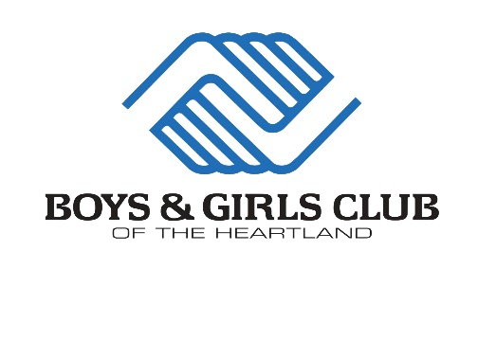

TITLE: Unit Director
DEPARTMENT: Operations
REPORTS TO: Area Director
FLSA STATUS: Exempt

PRIMARY FUNCTION:
The Unit Director is responsible for overseeing the planning, development, and evaluation of a specific unit for youth between the ages of 6 and 18 within a designated Club. Unit responsibility supports our priority outcome areas of Academic Success, Healthy Lifestyles, and Good Character and Citizenship. The Unit Director also provides leadership and supervision to assigned site directors, youth development professionals and volunteer staff. The help manage budgets and controls expenses as assigned as well.

KEY ROLES (Essential Job Responsibilities):
Leadership
- In conjunction with Site Directors, plan, develop, and evaluate services provided at Site/s to ensure quality of site.
- Oversee designated unit by being a part of the everyday operations.
- Plan, develop, and evaluate Unit programs, lessons, and activities within the site/s that create an optimal club experience for members that facilitates the completion of the Formula for Impact.
- Supervise Youth Development Professionals, Front Desk Employees, Site Directors, and volunteers in a professional and ethical manner and develop them through evaluations and coaching.
- Oversee Academic Success at Unit and helps initiate targeted strategies.
- Compile and present regular Unit reports reflecting appropriate activities, attendance and participation.
- Conduct regular staff meetings with Unit team.
- Conduct Site Director/YDP staff evaluations, ensuring the evaluations are delivered on a timely basis and submitted to the Area Director
- Assist with ensuring the attendance policy is followed and other attendance statistics for the Site staff and submit paperwork to the Area Director or their representative.
- Ensure grant deliverables are communicated and followed at Unit.
- Assist in the development of annual budgets.
- Utilize communication systems in place to maintain the operation of the physical properties and equipment of the Club.
- Implement Unit incentives.
- Ensure safety and environmental policies and regulatory requirements are met.
- Exercise authority in problems relating to members and utilize behavior management plans.
- Develop strategic alliances with schools, community members, club members, parents, families, and club staff.
- Develop, organize and oversee unit activities and family engagement events outside of regular club hours.
- Develop social media posts and website posts about programing at designated unit
- Supervise Summer Program and Camp Days.
- All other responsibilities as assigned.

RELATIONSHIPS:
Internal: Maintains close, daily contact with Club professional staff to interpret and explain organizational mission, program objectives and standards, discuss issues, and provide/receive information. Has contact with members as needed to discipline, advise, and counsel.
External: Maintains contact with external community groups, schools, members’ parents and others to assist in resolving problems and to promote Club services.

SKILLS/KNOWLEDGE REQUIRED:
- A minimum of one year work experience in a Boys & Girls Club or similar organization planning and supervising activities based on the developmental needs of young people, or equivalent experience
- Demonstrated ability in personnel supervision, facilities management, and the recruitment and retention of key personnel
- Ability to supervise, evaluate, and motivate staff
- Ability to relate effectively with members including discipline issues
- Working knowledge of budget preparation
- Demonstrated ability in working with young people, parents and community leaders
- Communication skills – strong communication skills, both oral and written; informing, listening, presenting, writing.
- Decision making skills – good judgment, systemic thinking, problem solving, performance organization and time management
- Planning skills – monitoring, organizational planning, ability to plan and implement quality programs for youth and to organize and supervise staff and members in a safe environment
- Relationship skills – strong customer service, strict confidentiality, ability to build relationships, and be a positive team player
- Valid State Driver’s License & Class E license

DISCLAIMER:
The information presented indicates the general nature and level of work expected of employees in this classification. It is not designed to contain, or to be interpreted as, a comprehensive inventory of all duties, responsibilities, qualifications, and objectives required of employees assigned to this job. Contents may be subject to change to meet the needs of the organization.

Signed by: _________________________________________________________
Employee Date

Approved by: _______________________________________________________
Area Director Date

Approved by: _______________________________________________________
Executive Director Date

